

American International University-Bangladesh (AIUB)  
**Department of Computer Science  
Faculty of Science &Technology (FST)  
Spring 19_20**

**<Student Accommodation>**

A software Engineering Sec: **<** B **>** project submitted

By

*Nusrat Zahan Pokrity (17-35105-2)*

The project will be Evaluated for the following Course Outcomes

|  |  |
| --- | --- |
| CO3: Choose appropriate software engineering model in a software development environment | Total Marks |
|  |
| Content Knowledge [5Marks] |  |
| Argumentation [5Marks] |  |
| Evidence of Argumentation [5Marks] |  |
| Completeness, Spelling, grammar and Organization of the Answer [5Marks] |  |
|  | |
| CO4: Explain the roles and their responsibilities in the software project management activities | Total Marks |
|  |
| Project Background Analysis [5Marks] |  |
| Project Role identification [5Marks] |  |
| Responsibility Description [5Marks] |  |
| Completeness, Spelling, grammar and Organization of the Answer [5Marks] |  |

**PROBLEM DOMAIN**

* 1. **Background to the Problem**

Problem statement:

Students face problems of accommodation, they come from different kind of places to do study in different Universities all over the country. They cannot get place to stay as their preferences, so they face many problems and it hampers their daily life and study too. Their family also get tensed about it. Sometimes innocent students get trapped in many ways by some frauds and they can get involved in many crimes. So a well and good place to stay is import.

For this problem students need to rush from here and there in order to get best accommodation services. Sometimes it becomes very difficult to find out which place or house will be best for to stay. But due to the monotonous life, it has become very difficult to go looking for it. So to solve these problems there will be an online accommodation service based app that will be easier for students. In the app there will be available and nearby houses, house’s facilities, house's rent cost, visiting time, house location etc. By using it student s can easily take decisions where should they go for the proper accommodation. Students can solve their accommodation problems by using this simple application.

There can be a solution to solve this problem. Nowadays of technology, people use technology more than anything. So we can use it for our wellbeing and save our time. Students can easily find their houses or rooms and other facilities by their own preferences. Owners are also be benefitted by this online application. Owner can easily contact to their clients and know their identity. There will be registration option to use this application that’s why house owner and students have to fill up the form by their real identification. So both side can be ensured about each other’s information

* 1. **Solution to the Problem**

**Proposed Solution:-**

The application that has been discussed above is an online services but we want to upgrade little bit more to make this more efficient and helpful. People are upgraded so much but still people prefer to go doctor’s chamber rather than online treatment. So, we proposed to create a system that will be beneficial and also valuable. We want to build the connection between the user and doctor directly. So the process is given below.

1. Every categories house or rooms will be available (high budget, medium budget, low budget etc.)

2. Every Owner must have a verification id to access and their profile have to include with house facilities, location, rent cost etc.

3. A student will register into the system by using personal information such as name, NID, photo, phone number, student information and Guardian’s information etc.

4. After entering the system they can view the Owner’s profile and choose their suitable house with the help of viewing House facilities and rent cost.

5. A student can choose and take rent the house or rooms as their preferences

6. User can pay offline or online.

So, It’s a simple application for any kinds of students.

1. **SOLUTION DESCRIPTION**

**Software Architecture**

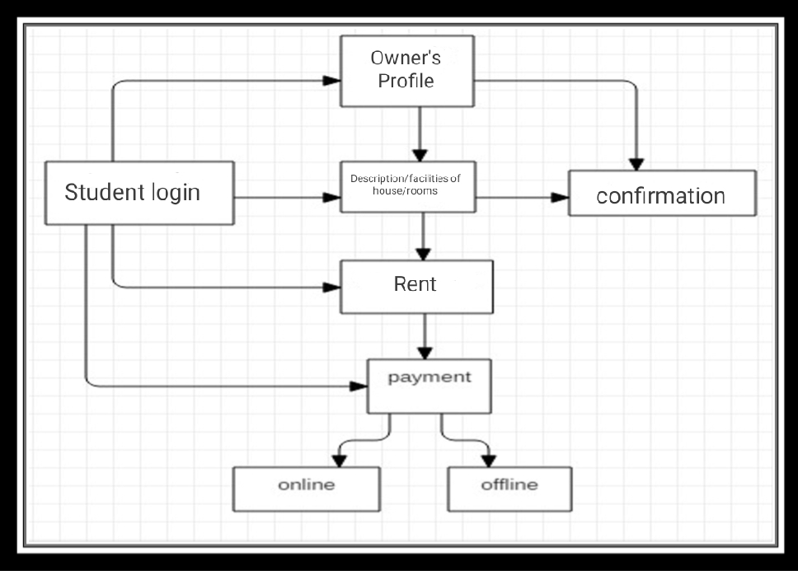

UML Diagram

Use Case Diagram:-

Case: Doctor facilities Andrew her every categories of doctor’s are present. Every house owner has a verified id and has to log into the system. In an openers’ profile there are available rooms, rooms photos, facilities, location, rent cost etc. Then the student must have a user id and has to go through user name or password. verification. User student can look forward for any suitable house or rooms by visiting owner’s profile. If user find any suitable profile then he/she has to go through the room confirmation process. For this a user can take the confirmation until its availability

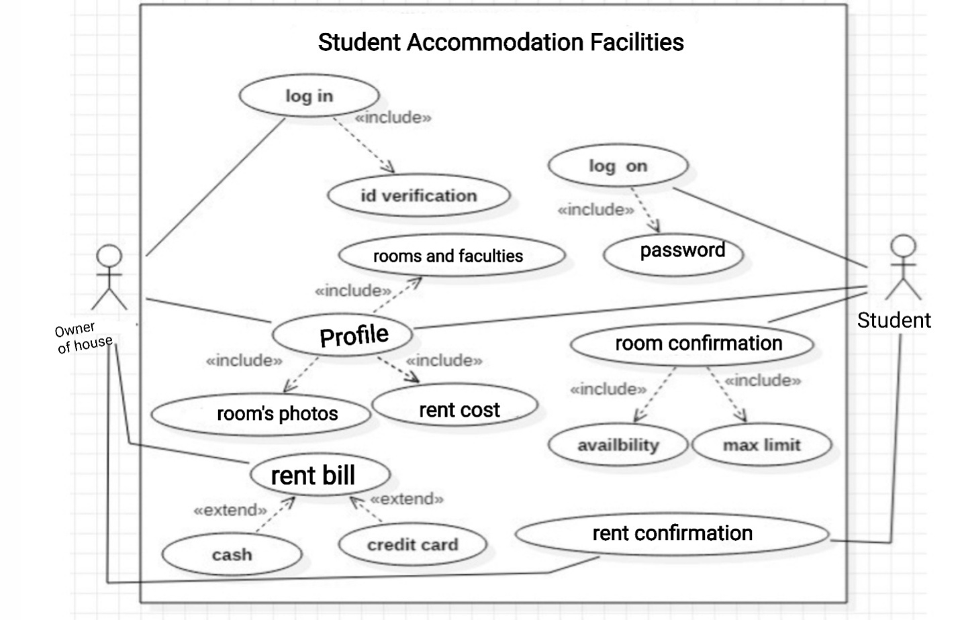

However, the use-case model shortly explained processes related to users. Some of the processes are related to only one user but some has more than one relations, such as checking Owner’s Profile or confirming the rooms in rent. All these requirements show what users need, what they would want to see, and what facilities to get to not be disappointed of renting the rooms.

Activity Diagram:

Student

Enter

Username

Remains many kind of room and room rent

Username

No

Yes

Yes

No

[If choose room]

[If available]

owner

Visit

profile

Confirmation

room

Confirmation

Room rent

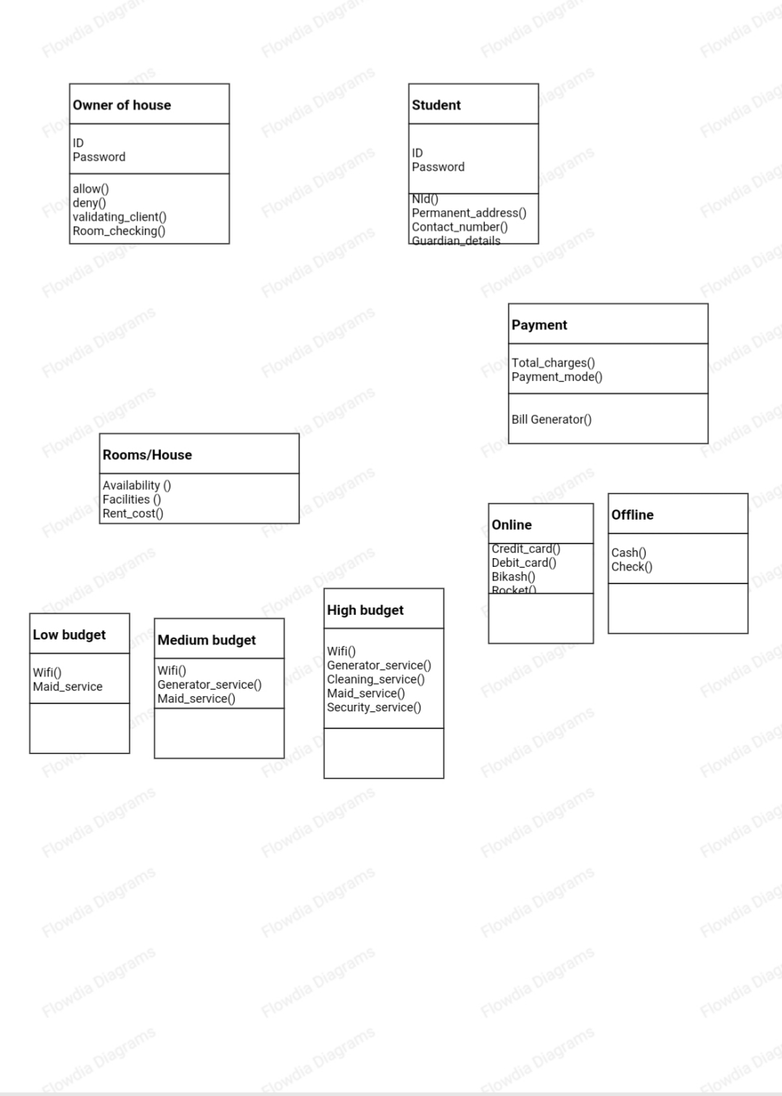**Class Diagram:**

ER Diagram:

1..*

1..1

1..1

1..*

1..*

1..*

Room

1..1

Credit

card

caard

cash

payment

pay

owner

student

profile

varify

visit

1..1

remain

Room rent

1..1

1..*

1..1

1..1

confermation

**SOFTWARE DEVELOPMENT LIFE CYCLE**

* 1. **Process Model**

For developing this project SCRUM model is selected. Scrum is an Agile. There are many other Agile in software development, for this project Scrum is suitable that’s the we have chosen this Scrum process of Agile methodology. According to our project, the requirements like accommodation facilities, rent cost changing, house changing and many other requirements will be changeable. That’s the reason requirements might be changed on user's preferences. Scum works on Sprint base, so requirements changing wouldn’t effect on full system.

Scrum is an agile process most commonly used for product development, especially software development. Scrum is a project management framework that is applicable to any project with aggressive deadlines, complex requirements and a degree of uniqueness. In Scrum, projects move forward via a series of iterations called sprints. Each sprint is typically two to four weeks long.

## **Scrum Overview - Introduction to Scrum Terms**

An introduction to Scrum would not be complete without knowing the Scrum terms you'll be using. This section in the Scrum overview will discuss common concepts in Scrum.

**Scrum team:** A typical scrum team has between five and nine people, but Scrum projects can easily scale into the hundreds. However, Scrum can easily be used by one-person teams and often is. This team does not include any of the traditional software engineering roles such as programmer, designer, tester or architect. Everyone on the project works together to complete the set of work they have collectively committed to complete within a sprint. Scrum teams develop a deep form of camaraderie and a feeling that “we’re all in this together.”

**Product owner:**The product owner is the project’s key stakeholder and represents users, customers and others in the process. The product owner is often someone from product management or marketing, a key stakeholder or a key user.

**Scrum Master:** The Scrum Master is responsible for making sure the team is as productive as possible. The Scrum Master does this by helping the team use the Scrum process, by removing impediments to progress, by protecting the team from outside, and so on.

**Product backlog:** The product backlog is a prioritized features list containing every desired feature or change to the product. Note: The term “backlog” can get confusing because it’s used for two different things. To clarify, the product backlog is a list of desired features for the product. The sprint backlog is a list of tasks to be completed in a sprint.

**Sprint planning meeting:**At the start of each sprint, a sprint planning meeting is held, during which the product owner presents the top items on the product backlog to the team. The Scrum team selects the work they can complete during the coming sprint. That work is then moved from the product backlog to a sprint backlog, which is the list of tasks needed to complete the product backlog items the team has committed to complete in the sprint.

**Daily Scrum:**Each day during the sprint, a brief meeting called the daily scrum is conducted. This meeting helps set the context for each day’s work and helps the team stay on track. All team members are required to attend the daily scrum.

**Sprint review meeting:**At the end of each sprint, the team demonstrates the completed functionality at a sprint review meeting, during which, the team shows what they accomplished during the sprint. Typically, this takes the form of a demonstration of the new features, but in an informal way; for example, PowerPoint slides are not allowed. The meeting must not become a task in itself nor a distraction from the process.

**Sprint retrospective:** Also at the end of each sprint, the team conducts a sprint retrospective, which is a meeting during which the team (including its ScrumMaster and product owner) reflect on how well Scrum is working for them and what changes they may wish to make for it to work even better.

Each of the Scrum terms has its own page within the Scrum section, so be sure to check out all the pages in the navigation.

* 1. **Project Roll Identification and Responsibilities**

Project management activities in software development is very important for reach it's goal. Requirement collection, design, testing, estimation, time box scope ,cost, team has to be done properly for a productive outcome. Management team mainly maintain it. Every role & responsibility is important for a successful project & it has to divided correctly.

So, In project development every role has a different responsibility. Scrum master, product owner, scrum team, client, management all these roles & their responsibility makes a project complete with the demand. Everything mainly happened with assumption. The more perfectly the assumption can be done the project will be more efficient .In the beginning of the project, Management distribute the responsibility & based on the project schedule the work goes on.

In this particular project rules are also same. As the project management play a vital role for any

project they will decide the distribution of the work. Here is some description about the roles & their responsibilities of this project:-

**Client:**

Client has some requirement how they want to develop their software. Client is connected although the project .After finishing every scrum client can give their feedback.

**Project Owner:**

Project owner is the representative of the client. If any client want they can choose any project owner for being their representative. Of course it is the mutual decision of scrum master, client as well as management. Thought out the project he/she will manage, control everything will do as situation demand.

**Scrum master:**

Scrum master has the responsibility to interact with project team, the management as well as with the client. Suppose, In this project if Nusrat Prokrity is project master. So, her responsibility is collect as much as possible proper requirements from client. Select perfect scrum team based on the project. Also good interaction with management team.

**Scrum Team:**

Based on the project scrum team is being created and with the demand after every scrum the team can be changed. After finishing every scrum based on the requirement & demand the team selection happened.

**Management:**

Management plays a vital role in a project. The final decisions, Agreements, negotiation etc done by this team. If in this project Foysol Ahmed, Nusrat Zahan, Md Tawheed Anjum is the management their responsibility is distribute the work properly. In which situation what will be the best decision they have to take for the betterment of the project. Any kind of negotiation, agreement etc are their responsibility towards the project.

**Effort Estimation Using WBS:**

|  |  |
| --- | --- |
| **Project Start** | **9/4/2020** |

|  |  |  |  |  |  |
| --- | --- | --- | --- | --- | --- |
| **Level** | WBS | Task Description | Start | End | Weightage |
| **1** | **1** | **Project design and scheduling** | **9/4/20** | **9/5/20** |  |
| 2 | 1.1 | Project feasibility report | 9/4/20 | 15/4/20 | 5 |
| 2 | 1.2 | Architecture design | 16/4/20 | 21/4/20 | 3 |
| 3 | 1.2.1 | Solution planning | 22/4/20 | 27/4/20 | 3 |
| 3 | 1.2.2 | Check the possible solution | 28/4/20 | 30/4/20 | 3 |
| 4 | 1.2.2.1 | Project statement of work | 1/5/20 | 2/5/20 | 3 |
| 4 | 1.2.2.2 | Make cases | 3/5/20 | 5/5/20 | 5 |
| 4 | 1.2.2.3 | Test the cases | 6/5/20 | 7/5/20 | 3 |
| 2 | 1.3 | Finalize and check the design | 8/5/20 | 9/5/20 | 5 |
| **1** | **2** | **Development** | **10/5/20** | **10/6/20** |  |
| 2 | 2.1 | Coding | 10/5/20 | 20/5/20 | 5 |
| 3 | 2.1.1 | Testing | 21/5/20 | 31/5/20 | 3 |
| 3 | 2.1.2 | Review and add new requirements | 1/6/20 | 10/6/20 | 5 |
| 1 | 3 | **Software deployment** | **11/6/20** | **3/6/20** |  |
| 2 | 3.1 | Final testing | 11/6/20 | 17/6/20 | 5 |
| 3 | 3.1.1 | Release beta version | 18/6/20 | 21/6/20 | 3 |
| 4 | 3.1.1.1 | Take the feedback | 22/6/20 | 26/6/20 | 3 |
| 2 | 3.2 | Release final version and monitoring | 27/6/20 | 30/6/20 | 5 |

Here, Total function points=57, our project team has estimated defined per Function Points of **5 hours/points.**

Total efforts=Total function points × Estimated defined per Function Points.

=57×5

=**285 person-hours**

So, it can be said that effort estimation corresponded with the WBS and schedule.

**Budgeting & Scheduling:**

Budgeting is the process of creating a plan to spend your money.

|  |  |  |  |
| --- | --- | --- | --- |
| Project stages |  | Percentage of overall budget | Budget=$30,000 |
| Planning & Documentation |  | 15% | 4500 |
| Development |  | 20% | 6000 |
| Testing |  | 15% | 4500 |
| Project management |  | 15% | 4500 |
| Server |  | 15% | 4500 |
| First phase marketing | Marketing | 20% | 6000 |

Project scheduling is a mechanism to communicate what tasks need to get done and which organizational resources will be allocated to complete those tasks in what timeframe.

Tasks and resources are identified and allocated in different activities in the projects

|  |  |  |  |  |  |  |  |  |  |  |  |  |
| --- | --- | --- | --- | --- | --- | --- | --- | --- | --- | --- | --- | --- |
| **Project schedule** | Week 1 | Week 2 | Week  3 | Week  4 | Week  5 | Week  6 | Week  7 | Week  8 | Week  9 | Week  10 | Week  11 | Week  12 |
| Project Feasibility report |  |  |  |  |  |  |  |  |  |  |  |  |
| Project Estimates |  |  |  |  |  |  |  |  |  |  |  |  |
| Architecture Design |  |  |  |  |  |  |  |  |  |  |  |  |
| Solution Planning |  |  |  |  |  |  |  |  |  |  |  |  |
| Project statement of work |  |  |  |  |  |  |  |  |  |  |  |  |
| Development Setup |  |  |  |  |  |  |  |  |  |  |  |  |
| Sprint Planning |  |  |  |  |  |  |  |  |  |  |  |  |
| **Sprint 1** |  |  |  |  |  |  |  |  |  |  |  |  |
| Software Design |  |  |  |  |  |  |  |  |  |  |  |  |
| Software Build |  |  |  |  |  |  |  |  |  |  |  |  |
| Software Testing |  |  |  |  |  |  |  |  |  |  |  |  |
| User review |  |  |  |  |  |  |  |  |  |  |  |  |
| Sprint Review |  |  |  |  |  |  |  |  |  |  |  |  |
| **Sprint 2** |  |  |  |  |  |  |  |  |  |  |  |  |
| Software Design |  |  |  |  |  |  |  |  |  |  |  |  |
| Software Build |  |  |  |  |  |  |  |  |  |  |  |  |
| Software Testing |  |  |  |  |  |  |  |  |  |  |  |  |
| User review |  |  |  |  |  |  |  |  |  |  |  |  |
| Sprint Review |  |  |  |  |  |  |  |  |  |  |  |  |
| **Sprint 3** |  |  |  |  |  |  |  |  |  |  |  |  |
| Software Design |  |  |  |  |  |  |  |  |  |  |  |  |
| Software Build |  |  |  |  |  |  |  |  |  |  |  |  |
| Software Testing |  |  |  |  |  |  |  |  |  |  |  |  |
| User review |  |  |  |  |  |  |  |  |  |  |  |  |
| Sprint Review |  |  |  |  |  |  |  |  |  |  |  |  |
| Software Deployment Testing |  |  |  |  |  |  |  |  |  |  |  |  |
| Software Production |  |  |  |  |  |  |  |  |  |  |  |  |
| Monitoring |  |  |  |  |  |  |  |  |  |  |  |  |

**Scheduling:**

**Risk Analysis:**

Risk analysis is the process of identifying and analyzing potential issues that could negatively

Impact key business initiatives or critical projects in order to help organizations avoid or mitigate those risks.

* + Risk analysis identifies the existing and possible threats that the project might encounter. Cover all the identified and unexpected risks and their mitigation techniques.

Risk analysis of our project is given below,

|  |  |  |  |  |  |
| --- | --- | --- | --- | --- | --- |
| Risk event | Impact | Probability | Risk level | Consequences | What to do |
| Schedule Risk | 5 | 3 | Medium | Project schedule get slip when project tasks and schedule release risks are not addressed properly. | Always monitor the project. |
| Budget risk | 4 | 2 | Medium | The project might get delayed if wrong budget was estimated. | Check the expenses always and always follow the budget table. |
| Technical risk | 4 | 2 | Medium | Technical risks generally lead to failure of functionality and performance. | Don’t change requirement continuously. |
| Unavoidable risk like govt. policy, the obsolescence of software | 5 | 2 | Low | Might get suspend the project or might make a huge change in the software | Should focus on strategic planning to mitigate such risks |

#### conclusion:

This project is mainly for student’s well being as they can get accommodation support and facilities easily. Especially for outside students . They suffer a lot of this accommodation problem. By using this app they might be benefitted . As this app is very simple to use So they can use for their daily life whenever they need to find new accommodation.